- Obtaining Process
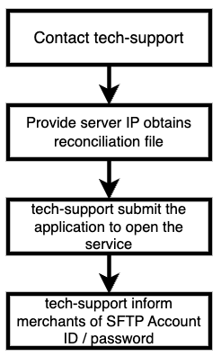
Picture 1- Process of how merchant obtain SFTP reconciliation files
- Process Instruction
Merchant Provide Server IP that obtains reconciliation files
The file path ， archive name and file types are described as follows：
SFTP file path：
/upload/#{[year]}/
（for example：/upload/2023/）

Archive file name：
{[member_id]}_#{[start_date]}_#{[end_date]}.zip
（for example： 203242353454634545_20230301_20230331.zip）
tips：member_id is the unique number representing the merchant entity-platform entity

File types | file name | Explanation
Bill file | P010123456789_bill_20230301_20230301_0.csv | For all merchants
Payment transaction file | P010123456789_payin_20230301_20230301_0.csv | For merchant who signed payment contract
Disbursement transaction file | P010123456789_payout_20230301_20230301_0.csv | For merchant who signed disbursement contract
 | P010123456789_settlement_sum_20230301_20230301_0.xlsx  P010123456789_pre_settlement_sum_20230301_20230330_0.xlsx  P010123456789_settlement_detail_20230301_20230330_0.xlsx | For merchant who signed payment contract，and need settlement file to check up account. The files need to apply separately

2、Files Field Definition
The reconciliation file is generated based on the dimensions of merchant entity and country at UTC+8 time zone. The Payment transaction file contains the details of orders including three transaction statuses which are success, failure, and closed; the disbursement transaction file contains detail of orders including three transaction statuses which are success, failure, and bounce back.

Bill file：
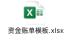
Payment transaction file：
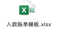
Disbursement transaction file：
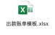
Settlement file：
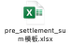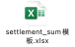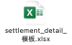

3、Generating Instruction
The reconciliation file will be generated before next day 12 o'clock.

